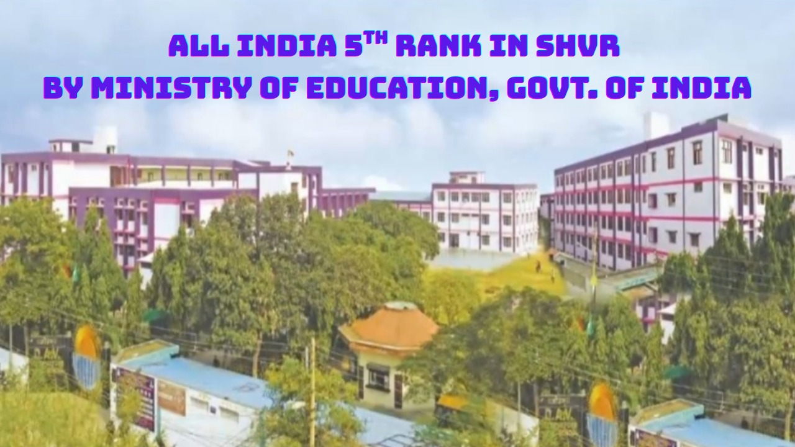

Congratulations‼
We are immensely proud to announce that, after securing top positions at the Block, District, and State levels, DAV Multipurpose Public School, Sector-15, Sonipat has achieved the 5th Rank at the National Level in the Swachh Evam Harit Vidyalaya Rating (SHVR) 2025–26, an initiative of the Ministry of Education, Government of India.
In recognition of this remarkable achievement, our school has been selected for the SHVR 2025–26 National Level Recognition Ceremony, to be organised by CIET–NCERT.
This prestigious honour is a testament to our unwavering commitment to cleanliness, environmental sustainability, and responsible citizenship.
We extend our heartfelt gratitude to our students, parents, teachers, support staff, and the entire school community for their invaluable contribution to this proud milestone.
Together, we continue to build a cleaner, greener, and more sustainable future!
